**DAILY ONLINE ACTIVITIES SUMMARY**

|  |  |  |  |  |  |  |  |  |
| --- | --- | --- | --- | --- | --- | --- | --- | --- |
| **Date:** | **12/06/2020** | | | | | **Name:** | **ANUSH RATNAKAR SHETTY** | |
| **Sem & Sec** | **4&A** | | | | | **USN:** | **4AL18CS08** | |
| **Online Test Summary** | | | | | | | | |
| **Subject** | |  | | | | | | |
| **Max. Marks** | |  | | **Score** | | |  | |
| **Certification Course Summary** | | | | | | | | |
| **Course** | **INTRODUCTION TO NEURAL NETWORKS AND DEEP LEARNING** | | | | | | | |
| **Certificate Provider** | | | **Great learning** | | **Duration** | | | **9.5 hours** |
| **Coding Challenges** | | | | | | | | |
| **Problem Statement1:Write a java program to find longest repeating sequence in a string** | | | | | | | | |
| **Status:Executed** | | | | | | | | |
| **Uploaded the report in Github** | | | | | **YES** | | | |
| **If yes Repository name** | | | | | **https://github.com/anushshetty30/lockdown-coding** | | | |
| **Uploaded the report in slack** | | | | | **YES** | | | |

Online Test Details:No online test

Certification Course Details: INTRODUCTION TO NEURAL NETWORKS AND DEEP LEARNING

As a part of continuation of my ongoing certification course ,Today have listened 8 videos each of duration 22,20,21,6,27,14,21,17 minutes

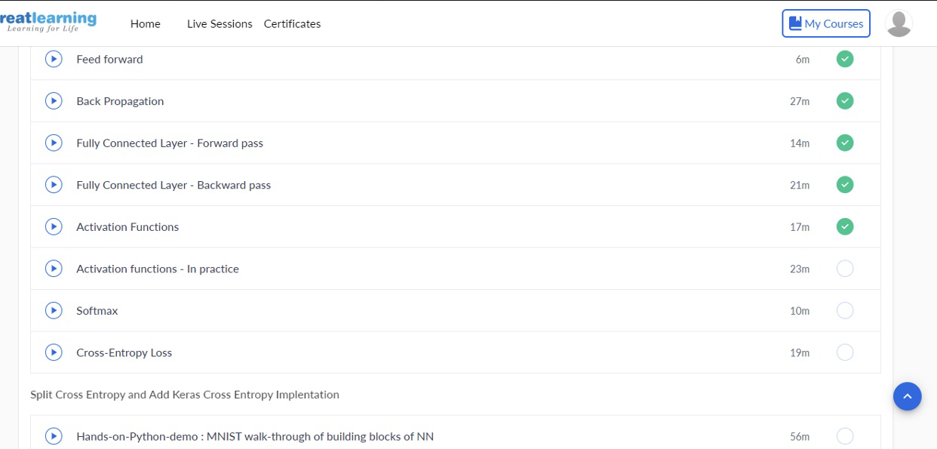

Certification details: WEBINAR ON SKILL DEVELOPMENT

On 11th June 2020, I had attended a webinar on skill development which was conducted by Brainovision .The duration of the webinar was 3 hours.

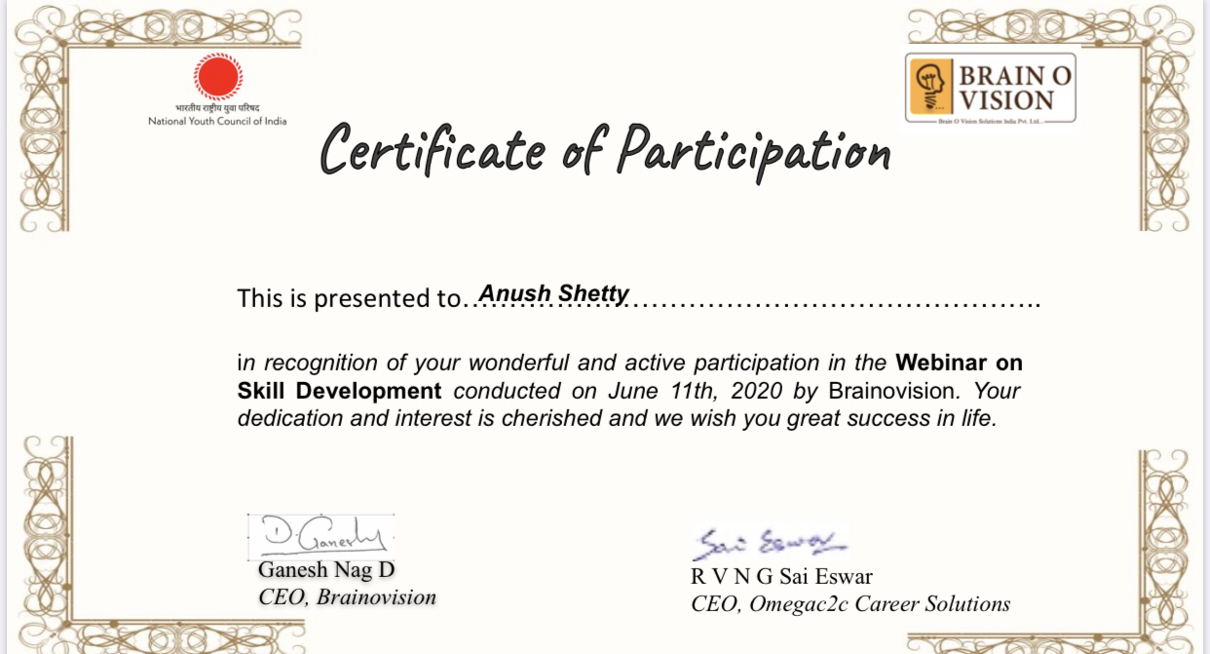

CODING DETAILS: Write a java program to find longest repeating sequence in a string